**NAME:** SAIRAM REDDY

**REGISTRATION NUMBER:** 20BRS1252

**WEEK 2 ASSIGNMENT**

**CREATE, UPDATE AND DELETE IN MYSQL:**

1. **CREATING TABLE IN MYSQL:**

create table StudentDetails ( RegNumber varchar (9) primary key ,

FirstName varchar (20) not null ,

LastName varchar (20) not null,

ContactNumber decimal (10, 0) not null,

cgpa decimal(3, 2) not null ) ;

insert into StudentDetails

values ('20BRS1200', 'Shreya', 'Ramarao', 8888866666, 9.55) ;

insert into StudentDetails

values ('20BRS1252', 'Sairam', 'Reddy', 9999988888, 9.00) ;

insert into StudentDetails

values ('20BRS1115', 'Krishna', 'Sarawagi', 6666644444, 9.66) ;

select * from StudentDetails ;

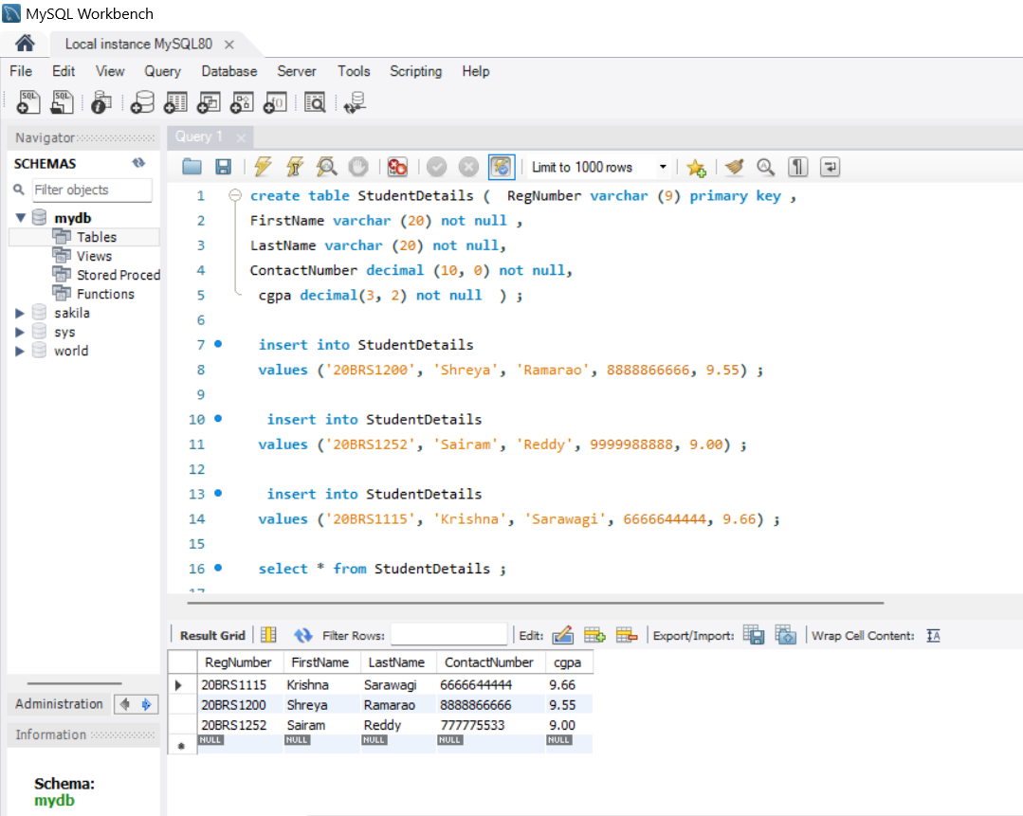

1. **Updating a table in MYSQL:**

update StudentDetails

set ContactNumber = 777775533

where RegNumber = '20BRS1252' ;

The above query modifies the value of the ContactNumber column for the record with RegNumber 20BRS1252.

1. **Delete query in SQL:**

We can delete an entire table or a particular record in SQL.

Delete from StudentDetails where RegNumber = ‘20BRS1115’ ;

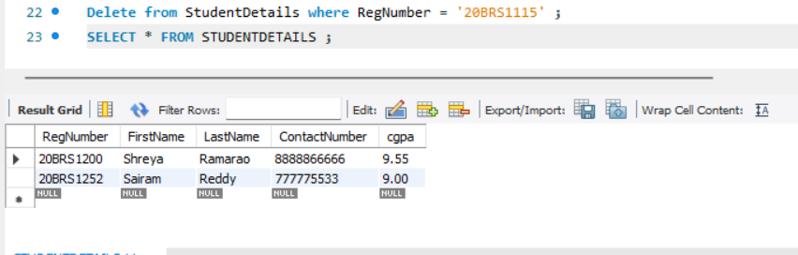

**CREATE TABLE AND PERFORMS JOINS ON THEM IN MYSQL:**

1. **Creating tables**
2. **Creating Salesman table**

use mydb ;

create table salesman (

salesman_id int ,

fullname varchar (40) ,

city varchar (20) ,

commission decimal (3,2)

) ;

insert into salesman values (5001, 'James', 'New York', 0.15) ;

insert into salesman values (5002, 'Paul', 'Rome', 0.13) ;

insert into salesman values (5003, 'Ferdinand', 'Paris', 0.13) ;

insert into salesman values (5004, 'Jimmy', 'London', 0.14) ;

alter table salesman

add primary key (salesman_id) ;

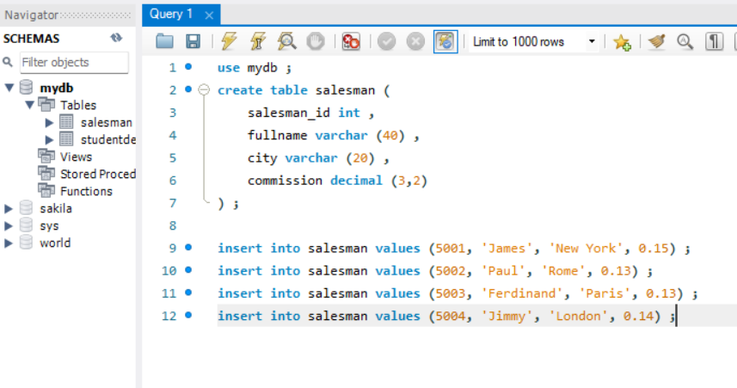

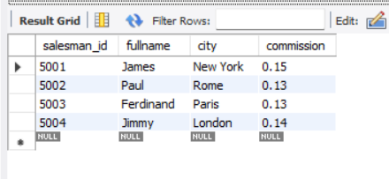

**b) Creating Costumers table:**

use mydb ;

create table customer (

customer_id int ,

cust_name varchar (40) ,

city varchar (20) ,

grade int,

salesman_id int ,

primary key (customer_id),

foreign key (salesman_id) references salesman (salesman_id)

) ;

insert into customer values (3002, 'Nick', 'New York',100, 5001) ;

insert into customer values (3003, 'Brad', 'New York',200,5001) ;

insert into customer values (3001, 'Graham', 'Paris',250, 5002) ;

insert into customer values (3005, 'Andrew', 'London', 300, 5004) ;

insert into customer values (3006, 'Geoff', 'California', 150, 5003) ;

insert into customer values (3004, 'Andrew', 'Rome', 300, 5002) ;

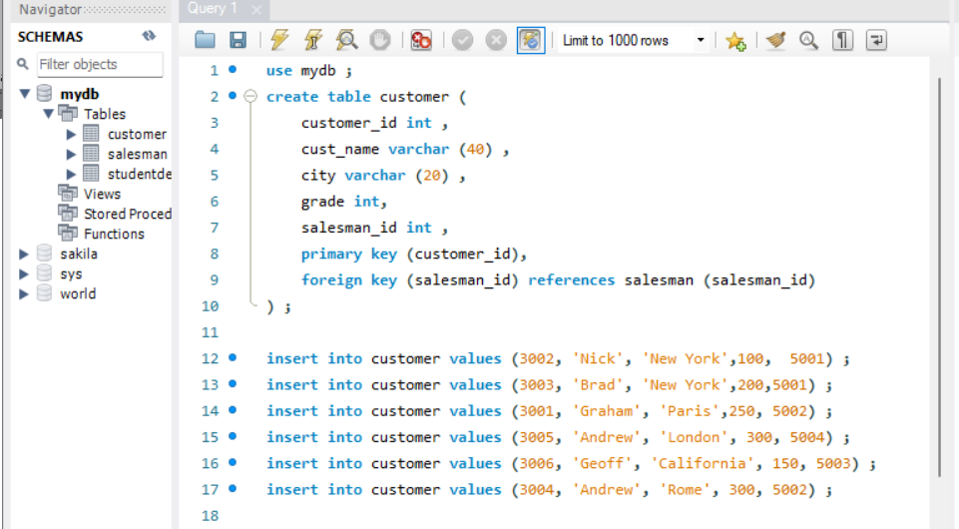

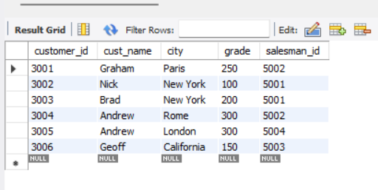

**INNER JOIN:**

select customer.customer_id, cust_name, salesman.salesman_id, salesman.fullname

from customer

inner join salesman

on customer.salesman_id = salesman.salesman_id ;

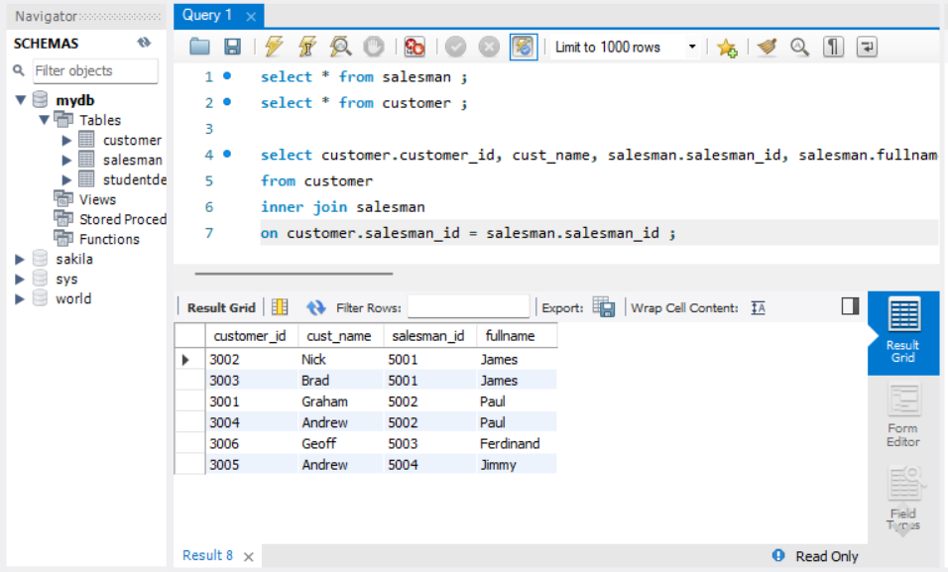

**LEFT (OUTER) JOIN:**

select salesman.salesman_id, salesman.fullname, customer.customer_id, customer.cust_name

from salesman

left join customer

on customer.salesman_id = salesman.salesman_id ;

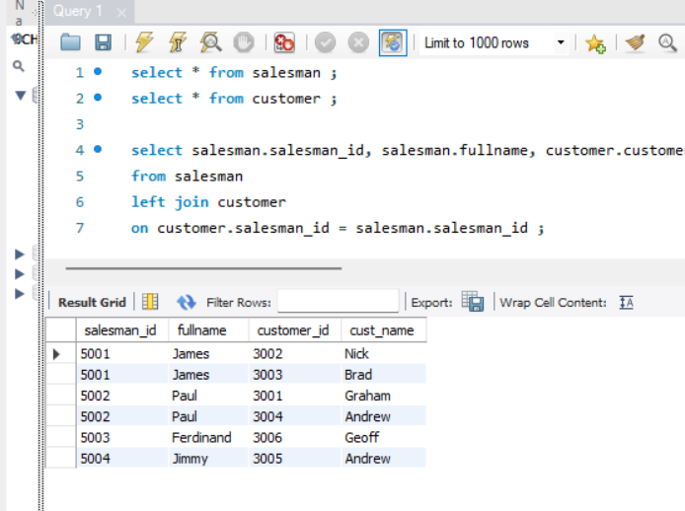

**RIGHT (OUTER) JOIN:**

select salesman.salesman_id, salesman.fullname, customer.customer_id, customer.cust_name

from salesman

right join customer

on customer.salesman_id = salesman.salesman_id ;

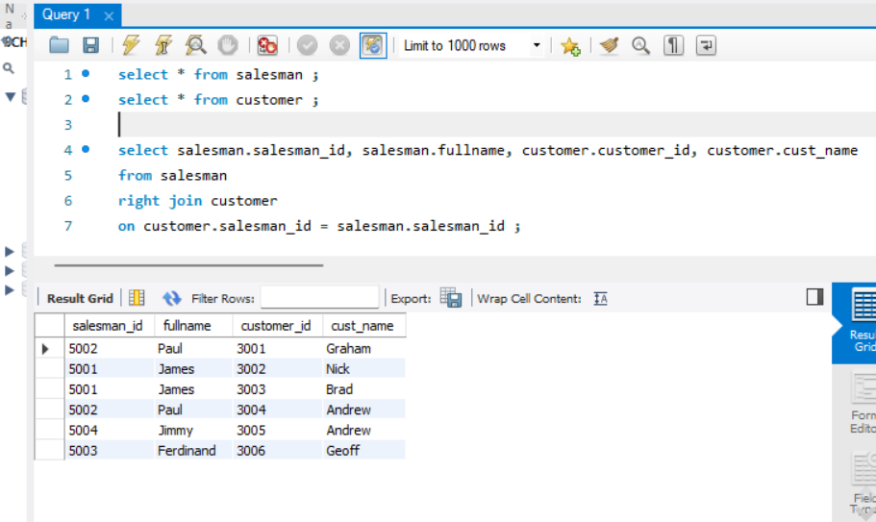

**FULL (OUTER) JOIN:**

select customer.customer_id, customer.cust_name

from salesman

full join customer ;

